

**Project Report**

**On**

**Tour and Travelling Management System**

**COURSE TITLE :** **Software Engineering Sessional**

**COURSE CODE :** **CSI 331**

**Submitted by :**

***Black Zombies***

**Name : Aditi Rajbongshi ID : CSE 063 07385**

**Name : Nazmus Sakib ID : CSE 057 06986**

**Name : Farzana Akhter ID : CSE 063 07425**

**Introduction:**

The project titled ‘Tour and Travel Management System’ is a dynamic website for tourism business. It is dynamic and responsive web design. It is also called travel technology solution for agencies and tour operation. Nearly everyone goes on a vacation for this ‘Tour and Travel Management System’ would play a vital role in planning the perfect trip. The Tour and Travel Management System allows the user of the system access all the details such as location, events etc. The main purpose is to help tourism companies to manage customer and hotels etc. The system can also be used for both professional and business trips. The proposed system maintains centralized repository to make necessary travel arrangements and to retrieve information easily.

**Scope:**

Tour and Travel System is an integrated software developed for our operating companies. The main aim of this project is to help the tourism to manage their customers, vehicles, and agent. It makes all operation of the tour company easy and accurate. The standalone platform makes tourism management easy by handing agencies requests and providing severs for the customers located at different parts of the various cities. Different modules have been incorporated in this project o handle different parts and sector of the tour management field.

**Objectives:**

The objective of this project is to develop a system that automates the process and activities a travel agency and customer details. The purpose is to design a system using which one can perform all operations related to travelling and sight-seeing. Some of the objectives are given below:

* **Directly Connected:** The System will provide to connect directly Customers and Agent through internet.
* **Modify and Delete Data:** This System provide facilities to modify and deletes tourist’s data as well as client data.
* **Feedback:** This System provide feedback mechanism for tourist.
* **Social Media Link:** This System provide some social media link.
* **Packages:** This System provide information about the Inbound and Outbound Tour Packages.
* **Tourist Database:** This System maintain and control the database of tourist’s information.
* **Displaying Places:** This System display attractive tourist places.
* **Services:** This System give a variety of travel services that will sure to match all your priorities.
* **Display Platform:** This System will provide display platform in where a tourist can find their tour places according to their choices. Also one can easily added to a group of people to reduce the cost of travel.
* **Enrich Experience:** This System also helps to develop tourism with different cultures so that they enrich the tourists experience.

Finally, we can say that This System will provide easy and efficient work for agency.

**Feasibility Study:**

The very first phase in developing any life cycle is preliminary investigation. In the preliminary study we examine the project feasibility.

This project has been tested in the following areas of feasibility:

* **Operation Feasibility**
* **Technical Feasibility**
* **Economic Feasibility**

**Operational Feasibility:**

It was decided that the proposed system could be created as a web based system that be operated by all the clients.

* The system is designed in such a way that it is easy to operate.
* The system does not involve any complex operations. It handles only simple data oriented functions.
* It is aimed at giving an easy way to generate reports.
* The functional accessibility is also structured in such a way it won’t take much time for anyone to get accustomed with the system.
* Amount of knowledge and expertise required for being able to use this system is not much more than what it requires to operate a computer system.
* The client must have only the basic knowledge of web browsers.

**Technical Feasibility:**

* The system has very simple structure and easy to understand body.
* Also software used to build the system is simple in their usage and functionalities.
* To operate this system only a web browser is needed. The system is platform independent and browser independent and support all kinds of web browsers like Google Chrome, Internet Explorer, Mozilla Fire fox etc.
* The system can be expanded if so decided.
* This system is technically more secure.

**Economic Feasibility:**

Economic analysis is most frequently used for evaluation of the effectiveness of the system. More commonly know as cost/benefit analysis. The procedure is to determine the benefit and saving that are expected from a system and compare them with costs, decisions is made to design and implement the system.

**Project Scheduling**

|  |  |  |  |
| --- | --- | --- | --- |
| **Activity** | **Description** | **Precedence** | **Duration (in week/s)** |
| **Analysis** | | | |
| 1 | On-site Meeting | None | 1w |
| 2 | Discussion with Stakeholder | 1 | 1w |
| 3 | Analysis Requirement | 1,2 | 1w |
| **Design** | | | |
| 4 | System Design | 3 | 3w |
| 5 | Database Design | 3,4 | 1w |
| 6 | Interface Design | 1,4 | 2w |
| **Development** | | | |
| 7 | Develop System Modules | 4 | 1w |
| 8 | Integrate System Modules | 7 | 1w |
| 9 | Perform Initial Testing | 8 | 1w |
| **Testing** | | | |
| 10 | Perform System Testing | 9 | 1w |
| 11 | Feedback & Releasing | 10 | 1w |

**Gantt Chart:**

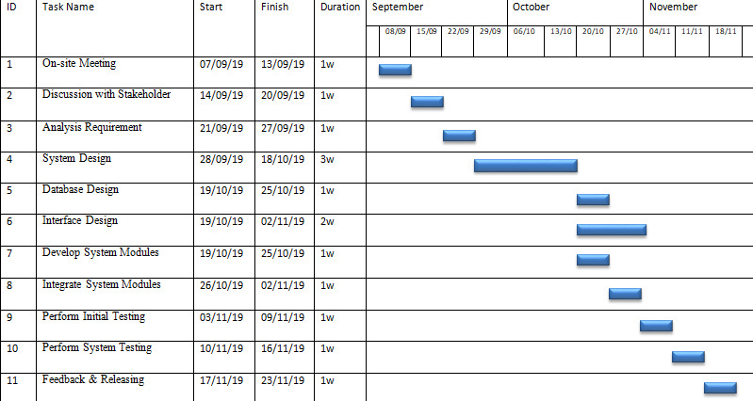

**Risk Analysis:**

* Identify potential travel risk and security risks, how to reduce or avoid them and how to respond to emergencies when they occur.
* Agree on guidelines for handling emergencies and contacting parents.
* Make certain that all participants register for travel insurance.

**Conclusion:**

Tourism is currently recognised as a global industry which is highly growing at a high rate like other industries. There are many different activities occurred in tour activities. ‘Tour and Travel Management System’ is web based application helps in online distribution of tour packages, hotel, hotel properties, transfer etc. This system can be fully customized with integration different API’s. It has friendly environment that connects customer willingly. Finally, we can say that this web based application will help tour manager to control and handle the tour related activities effectively and efficiently.